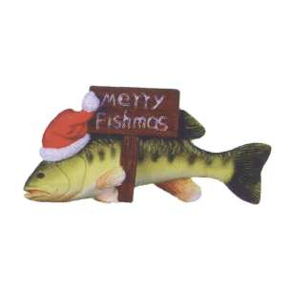Kasting Line

Little John Conservation Club December 2018

The Board of Directors would like to wish a Merry Christmas and a Happy New Year to all Little John members

**Sixth Annual Raffle**

The Board of Directors will be operating the Sixth Annual Raffle in 2019. The raffle was implemented as a way to supplement the annual membership dues. The funds from the raffle are for present and future projects on club grounds.

A couple of reminders to the membership about the raffle:

* It is very important to remember that the annual club dues can remain where they are because of the additional income the raffle brings to the club. The more tickets that are sold, the better the chance that dues will remain where they are today in the future.
* All members are required to turn in their unsold tickets before the raffle drawing. To ensure that we can make every effort to sell them.

**The Sixth Annual Little John Raffle prizes are:**

1. Springfield Armory Saint 16” Black STD Mid Length Tactical Rifle
2. Springfield Armory XD .45 5" Black MOD-2 HC
3. Springfield Armory XD 9MM 5” SS MOD-2 HC
4. Springfield Armory XD .45 3.3” Black SC MOD-2 HC
5. Springfield Armory XD 9MM 3” BLK SC MOD-2 HC
6. Trolling Motor
7. 10’ Kayak
8. Little John Membership
9. Little John Membership
10. Little John Membership

Tickets will be on sale in early January. The drawing will be held at the club picnic on June 23, 2019. **The three paying members that sell the most tickets get their membership dues paid the next year.** For more information contact Dennis Prather 309-368-1164 or Ed Mallory 309-337-1707.

**Guide to the 2019 LJCC Raffle**

Participants should number all prizes from 1 to 10, with 1 being the most desired prize and 10 being the least desired prize. If your ticket were drawn, you will win the lowest numbered prize that is available.

Memberships given away are for the first year’s dues and initiation fees. Any applicable stickers needed for 2019 must be paid in 2019. The winners must pay regular dues, workday fees and any applicable stickers in 2020 and beyond.

By obtaining a raffle ticket, you attest that you are a law-abiding citizen of good moral character. That you may legally possess a gun(s) won, have the intention of using a gun(s) only in a legal and safe manner. Will or have already obtained instruction in the safe use, and operation of the gun(s) won.

You must be at least 21 years old and a legal resident of the United States to obtain a ticket.

Winners must be at least 21 years old to take possession of a handgun and successfully pass applicable background checks.

ALL PRIZES MUST BE CLAIMED, AND TRANSFER COMPLETED WITHIN 90 DAYS OF THE SCHEDULED DATE THE TICKET IS DRAWN

Any prizes not claimed will become the property of the LJCC

LJCC makes no warranty of prizes; winners will deal directly with the manufacturer if a problem arises.

LJCC makes no claims of suitability for the purpose of prizes won.

The top 3 selling, paying members to get their dues paid the following year (officers, board members, committee heads or other comp members are excluded from this). It does not include workday fees or any applicable stickers needed.

LJCC limits any and all liability to the purchase price of the ticket obtained. If you have any questions, please call Dennis Prather 309-368-1164 or Ed Mallory 309-337-1707.

**Chili Supper**

The chili supper will be February 23rd, 2019 at 5:30 pm to 7:00 pm at the American Legion in Williamsfield, IL. Located on Route 180 next to the grocery store and FS gas station. Prices for this year’s chili supper will be $9.00 per family, $4.00 for a single person and $1.25 for children. Club meeting will follow at 7:00 pm.

**Clothing**

Clothing with the Little John Conservation Club Logo is available. Stephanie Landon is managing the clothing, and she usually has it available at some of the meetings and workdays. If you are interested in purchasing any items or placing a special order, let her know. There are hats, t-shirts, hooded sweatshirts, and, etc. If you would like to call her for some clothing, her number is 309-231-8539

**Dues**

The Board of Directors has decided that all dues are to be in an officer’s hand by March 31st of each year, like our bylaws state. In the past members were given a little leeway, and the board accepted dues that were postmarked on March 31st. Because of the inconsistency with USPS. And the need for the board to be able to draw for new members in a timelier manner, all dues must be in an officer’s hand by March 31st of each year. If they are not in the hands of an officer, your membership will be lost.

**2019 Membership Dues Structure**

Regular Club Dues $100.00

Work Day Fee $50.00

2nd Work Day Fee $50.00

Extra Auto Decals $1.00

Keys $5.00

Boat/Camper/Tent Sticker $1.00

R/V camping sticker $60.00 ($10 from every sticker sold to be put into camping fund for future repairs and expansion)

*Charter, 30-year members and comp members only have to pay $10 for their annual membership and are not subject to a Work Day fee. All other fees are the same. Dues are payable January 1, 2019. To get a recommendation card, you have to have your dues paid by March 15, 2019. To keep your membership, your due must be in the hands of an officer by March 31, 2019. This also applies to the recommendation cards. DO NOT FOLD your recommendation card.

**Please make check payable to Little John Conservation Club and mail to:**

**Little John Conservation Club**

**P.O. Box 113**

**Victoria, IL. 61485.**

**In Memorium**

Jeremy Johnson

Jim Cation

**Little John 2019 Planner**

**\*\*Please Note Meeting Times\*\***

**January**

1st Dues Payable.

**27th Workday 8am – Noon.**

28th Board Meeting 6pm Clubhouse

**February**

3rd Alternate Workday

23rd Chili Supper 5:30pm at Williamsfield American Legion 7:00pm Meeting ****SATURDAY****

24th Workday 8am – Noon

25th Board meeting 6pm Clubhouse

**March**

1st Annual Dues are due.

3rd Alternate Workday.

15th Deadline for paying your dues, and get a recommendation card.

31st Deadline for paying your dues and keep your membership.

**April**

4th Board Meeting for drawing new members. 6pm Clubhouse.

22nd Regular meeting 6pm Clubhouse. Greeting of new members.

27th Work Day 8am - Noon

29th Board meeting 6pm Clubhouse.

30th Kasting Line estimated arrival.

**May**

5th Alternate Workday (April)

18th Work Day 8am – Noon (Saturday)

19th Alternate Date for May work day.

20th Board meeting 6pm Clubhouse

25th Beach Opens

**June**

23rd Club picnic, 1pm. **Kids Fishing Derby; 15 and under. Registration: 10:30am. Fishing starts: 11:00am.**

**Meeting @ 1:45pm**

**Raffle drawing at 2:00pm.**

Nominating committee formed.

**July**

22nd Board meeting 6pm Clubhouse.

**August**

15th Deadline for Astrodome reservations.

19th Regular meeting 6pm Clubhouse. & Board meeting right after regular meeting.

15th Kasting Line estimated arrival.

Beach closed when school is in session.

**September**

2nd Beach closed for season @ dusk.

16th Board meeting 6pm Clubhouse.

21st Workday 8am – Noon (Saturday).

28th Alternate Workday.

**October**

**All boats need to be removed from Club grounds before the October workday.**

**1st Youth Archery Deer Hunting Starts**

**12th Halloween Party**

21st Regular meeting 6pm Clubhouse

27th Workday 8am – Noon

28th Board meeting 6pm Clubhouse.

**November**

1st Adult Deer Archery Starts.

3rd Alternate Workday

25th Board meeting 6pm Clubhouse.

**December**

15th Kasting Line estimated arrival.

16th Regular meeting 6pm Clubhouse.& board meeting

**Numbers You Can Call**

President: Jerry Fox 309-879-2626

Vice President: Butch Kimler 309-639-2263

Sec/Tres Dennis Prather 309-368-1164

Board Member: Denny Smith 309-639-4206

Board Member: Cory Tucker 309-337-7989

Board Member: Blue Carlson 309-337-9764

Board Member: Bill Tucker 309-371-6044

**Committee Chairpersons**

Committee heads do a lot for the club, but over the years we have seen a decrease in meeting attendance by our committee heads. Committee heads are supposed to attend at least ten meetings per year and three of the workdays per year. The reason for this is to bring ideas and recommendations to the board on how to improve our club. Because of this dedication to the club, they are given a comp membership. If you are interested, please contact your president Jerry Fox.

Astrodome: Tom Ryner & Bill Sornberger

Beach: Shelly Ponce

Camping: Kelsey Prather

Clothing: Stephanie Landon

Equipment: Ryan Stone & Pat Collopy

Fishing: Rob Mersman

Finance: Rachel Davis

Game & Cover: Roger Egnor

Grounds: Jeff Palmer

Hunting: Heath Smith

Kasting Line: Chad Rogers

Lakes: Alec Rabas

Legislative: Steve Davis

Shooting Range: James Nelson

Youth: Stephanie Landon

Raffle Ed Mallory

Raffle Prizes Steve & Beth Thomas

**Fish Limits**

Fishing limits must be strictly adhered to, at all times! The limits are posted: on signs all over the club grounds, on the back of your membership ID card and in the ground rules. Not knowing the fishing limits is unacceptable. Know your limits; if you see someone exceeding the limit let a board member know. Also, there will be some changes fish limits effective at the beginning of April 2019. Please see below:

* Long Lake – Bass will be catch and release, Crappie limit will be reduced from 15 down to 5
* Club Lake – Bass limit to remain the same, with guests able to keep a limit of 6
* Deer and Duck Lakes – Catch and release on all species until further notice

**Ice Fishing Safety**

The Board of Directors would like to remind all members that ice fish this winter, to please use your best judgment when doing so. If you have doubts about the ice, it’s best to error on the side of safety and don’t fish.

**Pet Etiquette**

If you bring your pets to the club, please make sure you keep them on a leash and clean up after them at all times.

**Christmas Trees**

The fishing committee would like collect all real Christmas trees to use for fishing structure. Trees can be dropped off on the west side of the wood pile or at Rob Mersman’s house in Galva. Please call Rob Mersman with any questions at 309-853-7132.

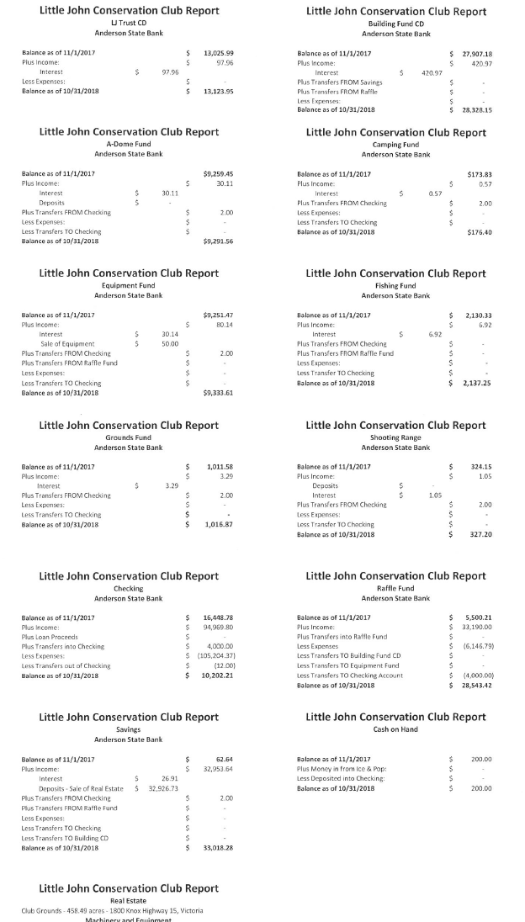**Audit**

